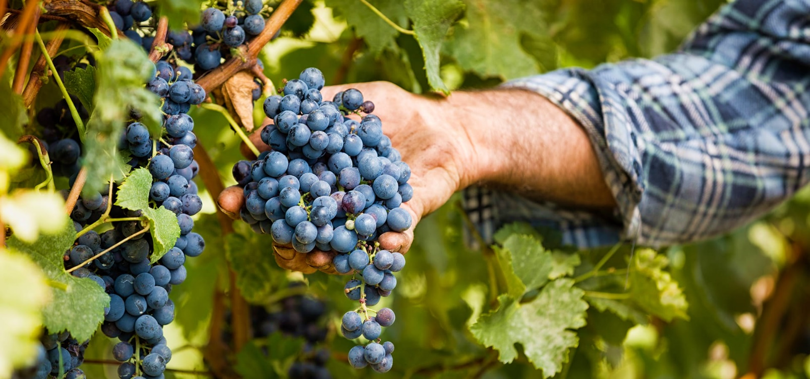

**UGA Vineyard Production Workshop**

March 15th

Location: Yonah Mountain Vineyards, 1717 Highway 255 S, Cleveland, GA

Cost- $15

8:45-9:30- Registration

9:30 – Welcome

9:40-10:30 – Phil Brannen, UGA Small Fruits Pathologist – Down Mildew update on resistance discoveries

10:35- 11:35 – Tremain Hatch- Virginia Tech Extension --New vine establishment. Hole preparation/training/tubes/training

11:45-12:30 –Lunch

12:30- 1:15 – Wayne Mitchem, UGA/ NCSU Weed Specialist – Update on weed control and using pre-emergent / Sucker Control

1:25-2:00 – New Viticulture Website Unveiling. Review of resources

2:00- 2:45 – Round table discussion of submitted topics.

3:00-- Dismissed